Enterprise at Salford:
Becoming
Self-Employed
Part of the North West HE Enterprise Champions Ph2 Project
Supported by:

Introduction
So you’ve got a business idea and now you want to develop it further…we are here to help!
In this booklet you will find information on how to become self-employed and how to go about starting your own business. We have added many links to valuable resources so you can do further research on your idea and gain a bit more knowledge about the start-up process.
Within this booklet you will find information on:

- How We Can Support You
- Becoming Self-Employed
- Business Motivation

- The Benefits and Challenges of Self-Employment
- Entrepreneurial Skills
- Market Research
- Your Business Model

- Types of Businesses

- Business Planning
- Your Business Pitch
- Resources and Funding

The next step is to begin working through this booklet, which will help you to clarify and research your idea further and establish the next steps on your business journey.
Please book in for a one to one appointment to start your business mentoring and bring this booklet with you to best asses your needs. During this appointment we will discuss your business idea in more detail, see what training you can take part in and discuss what funding and support you can access to grow your idea into a viable business.

What Support Can We Offer You?
Enterprise Academy
Join us in weekly master classes facilitated by industry experts that can help you stand out from the crowd. These workshops will help you with every aspect of business planning and developing your entrepreneurial and employability skills. You will also find out about business competitions and funding available for your projects.
http://www.careers.salford.ac.uk/page/enterpriseevents

1-2-1 Support
Do you have a business idea but are unsure of what to do? Book a 1-2-1 appointment with one of the experienced business advisors at http://www.careers.salford.ac.uk/enterprise and learn how to turn your dream into reality.
Business Boot Camp/Going Freelance
These are exclusive intensive two day events for our students and graduates who are serious about setting up in business. Our experts will take you on a practical, informative and hands-on journey. You will discover the key elements of successfully starting and running your own business.
http://www.careers.salford.ac.uk/page/businessbootcamp
Online Resources
View online annotated recorded resources through the Enterprise blackboard site and the enterprise website http://www.careers.salford.ac.uk/page/enterprise-resources
Entrepreneurs at Salford/Enactus
These are the University of Salford enterprise student societies that all students can engage with. Any student from any degree discipline can tap into any of the enterprise initiatives available at the university. These societies work on real life projects, which help them develop their skills and knowledge and gain ‘real world’ experience that employers’ value.

Volunteering
Get involved with our volunteering team and volunteer on one of our projects, get involved in a one-off opportunity or find exciting opportunities on our volunteering database!
http://www.careers.salford.ac.uk/volunteering
Postgraduate Boot Camp
This is an exclusive intensive one day event our students and graduates who are serious about setting up in business. Our experts take students on a practical, informative, hands-on journey. Over the day students discover the key elements of successfully starting and running their own business.

PG Enterprise Futures Conference
Enterprise Futures is a one day event jointly run by the Universities of Salford, Manchester and Manchester Metropolitan, and is one of the leading events for postgraduate student entrepreneurs in the UK. The event featuring our signature tagline ‘Inspiration, Collaboration, Opportunity’ aims to illustrate the possibilities associated with being more enterprising in your research, starting a business.
Tier 1 Graduate Entrepreneur Visa
The Tier 1 (Graduate Entrepreneur) category allows international graduates to extend their stay after graduation to establish one or more businesses in the UK. The University of Salford are now able to sponsor 10 students / graduates (of less than 1 year) on a Tier 1 Graduate Entrepreneur visa.
Please visit to read the eligibility requirements:
http://www.careers.salford.ac.uk/page/tier1-visa

Make a Difference/Start-Up Funding - Cash Awards up to £1000

Are you seeking funding to start-up your new business? Are you looking to set up a sustainable venture that has social impact or a normal business? We have cash grants available of up to £1000 to get your business off the ground. There are two funding application deadlines throughout the year; the first one being towards the end of Semester 1 and the second being towards the end of Semester 2. Students who are looking to apply, should engage with our enterprise activities and book an appointment to discuss the application before submitting. http://www.careers.salford.ac.uk/page/enterprise-funding
Innovation & Incubation
Are you interested in starting your own company? The University of Salford has its own business incubation facilities for business start-ups offering you a fantastic support network to help your business get off the ground.
http://www.careers.salford.ac.uk/page/incubation-office-space
Pop-Up Shops
The Pop-Up Shops allow you to test your entrepreneurial capabilities to sell your wares and goods to staff and other students on campus and within the local community. We run this at least once a year, during the Christmas period.
Contact Us
Email: enterprise@salford.ac.uk
Tel: 0161 295 55088
Facebook: Enterprise at Salford
Twitter: EnterpriseUoS
The Enterprise Team
Dominic Martinez - Head of Business and Enterprise
Justyna Orzechowska - Enterprise Champion
Jenny Warburton - Enterprise Teaching Project Manager
Lauren Adams - Student Life Co-ordinator

Becoming Self-Employed
Self-Employment is an increasingly popular way of work- it means using your talents or developing your business idea. For some occupations, working freelance is the main way of pursuing their careers. Graduates wanting to enter careers in IT, Performing & Creative Arts, Media, Fitness & Health are choosing the freelance path. Many companies turn to freelance workers to fulfil their ever-changing needs. Starting a Business is also an attractive alternative to graduates who are looking for more freedom over their own destiny along with a chance of reaping substantial financial rewards. Before considering self-employment, graduates should be aware that they will need a lot more than a business idea to create a successful business. In this guide we will outline some of the most important areas that people need to consider before setting up a business or going freelance.
You can become self-employed by:
- setting up a business, either on a full-time basis or alongside a part-time job
- working as a freelancer or contractor
- buying into a franchise
What will your business be?

Briefly outline your business idea:

Business Motivation
Why become self-employed? There are many reasons and benefits why people choose this career path:
- the desire to sell their skills and/or expertise;
- the desire to prove an idea;
- because they relish the challenge;
- wanting to generate a second income stream;
- reaction to an ill-informed first career decision;
- peer or family pressure;
- a feeling that there are no other options.

Your Reasons for Self-Employment
What are your reasons for wanting to work for yourself? Are you a risk taker? What strengths and weaknesses do you have – be honest with yourself – that will help or hinder. Do you have any practical experience of running a business? If not, what skills and knowledge do you have which will be useful? How do you feel about long and perhaps unsociable hours, particularly in the early stages of setting up the business? The VAT inspector is unlikely to accept a night out as an excuse for returns not being on time!

What do you want from your business?
What do you want from your business? | Importance  High/Low | Things to consider
Will running your business suit you?
Do you like taking risk?
Love it 1 2 3 4 5 Hate it

Do you like taking responsibility?

Love it 1 2 3 4 5 Hate it

Do you like working on your own?

Love it 1 2 3 4 5 Hate it

Do you like taking the initiative?

Love it 1 2 3 4 5 Hate it

Are you happy rising to a challenge?

Love it 1 2 3 4 5 Hate it

Do you like working hard?

Love it 1 2 3 4 5 Hate it

Do you like getting a reward for your efforts?

Love it 1 2 3 4 5 Hate it

Do you like have to find things out?

Love it 1 2 3 4 5 Hate it

Do you like paperwork?

Love it 1 2 3 4 5 Hate it

Do you like meeting deadlines?

Love it 1 2 3 4 5 Hate it
The Benefits and Challenges of Self-Employment

Benefits
- Freedom to choose your project
- Being your own boss
- Control over the work that you take on
- Earning more money (possibly becoming rich)
- Working fewer hours
- Independence and freedom to make your own decisions
- Variety and choosing work you enjoy
- Fitting work around your lifestyle

Challenges
- You do everything yourself and are responsible for the day-to-day running of the business.
- Large salaries or income are rare in the early days. Need for personal financial investment in the business

- Competition, economic fluctuations and changes in consumer markets may occur.
- You need to offer a product or service for which there is a demand.
- You alone are accountable. Taking an unwise decision could reduce your income.
- Expanding too rapidly or, conversely, not being quick to seize a chance might be problematic.
- Working from home is most effective when you have the space and facilities to do so.
- Pressures from clients and customers, who will often dictate your working hours.

- By not being employed, you risk losing a range of benefits and a support infrastructure.

- You will have to make your own tax, pension and health insurance arrangements.

Entrepreneurial Skills
Possessing entrepreneurial skills is vital to starting a new business. However these skills are also needed when you are pursuing other forms of employment. Many recruiters require you to demonstrate commercial awareness and enterprise skills. It is important that you reflect on all of your talents and work out whether you lack any of the skills essential to the success of your business You will be able to acquire these skills and techniques through attending our workshops and being involved in an Enterprise Society.
Entrepreneurial Skills include:
- Excellent Communication Skills
- Flexibility
- Determination
- Opportunity Awareness
- Networking Skills
- Organization Skills
- Customer Service
- Computer Literacy
- Commercial Awareness
- Self-Motivation

Entrepreneurs have very distinctive characteristics and can often be recognised by the fact that:

- They are people who create economic and social prosperity
- They are agents for change – see opportunities and develop them
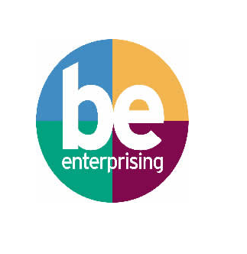
- Entrepreneurs do things that make a difference
They have the following essential traits:
- Willingness to take risks
- Acceptance of uncertainty
- Natural networker
- Self-discipline
- A total commitment to hard work
- Being aware of limitations
- Striving for speed, efficiency and quality
- Passion
- Energy
- Creativity
Thinking of Yourself as an Entrepreneur
Being an entrepreneur means you will need to use a lot of different skills to fulfil the roles your business requires to run. Start thinking about the skills and knowledge you currently have, what you need to develop.
Your Skills
Rate your strengths, skills and experience Rate yourself on your ability to carry out the following tasks, be honest so we can identify the things to work on:

Your Strengths | Your level
 | None | Poor | Fair | Good
Self-confidence
Self-determination
Being a self-starter
Judgement
Commitment
Preservation
Initiative

Business activity | Your ability
 | None |  | Poor |  |  | Fair | Good
Researching your idea or market
Finding premises
Preparing a business plan
Preparing cash flow forecast
 | None |  | Poor |  |  | Fair | Good
Raising start-up funds
Dealing with banks and financiers
National Insurance, VAT and tax
Bookkeeping
Costing products and services
Designing promotional material
Writing copy of sales material
Dealing with customers
Selling face to face
Recruiting staff
Employing staff
Dealing with staff
Purchasing stock and equipment
Stock control
Writing business letters
Health and safety requirements
Insurance and other stationary requirements
Consumer law

Summarise any experience that you may already have which will help you develop your business.

Where are the gaps in your skills and where do you need to develop?

FURTHER ACTION:
Think about your strengths and weaknesses and complete a SWOT analysis. How might you be able to use these to your advantage? Download the template here:
http://www.businessballs.com/free_SWOT_analysis_template.pdf
Take the Enterprise Catalyst Quiz and download your entrepreneurial profile: https://www.enterprisecatalyst.co.uk/
Your Market
What exactly is your idea and is there a market for it? There is no alternative for good market research. Knowing who your customers are and who your competition is can give you the confidence to position the business to its best advantage.
Before your business can realistically or effectively begin a marketing campaign, you will need to be able to answer two vital questions:
1. Who is your target market?
2. What does your target market want or need that your business can provide?
Without detailed and precise answers to these questions it will not be possible to define your marketing strategy, or implement an effective sales and marketing plan.
Having detailed knowledge about your intended audience in terms of who they are and what they really want puts a new business in a commanding position making the task of starting a new business that much easier.

Your first job when profiling a target market is to be able to precisely identify who your ideal or potential customers are. You will probably already have a good idea about the groups of people or types of businesses you think you can sell your service to. Where individual customers are concerned, they may be people of a certain age, gender, socio-economic status, occupation, or part of a group with common or special interests such as sports or hobbies. Business customers may be located in a specific area, or in a particular sector, or they could have similarities in terms of the customer groups to whom they sell. Can you accurately describe their characteristics?
Having selected your ideal customer groups, you will now need to be absolutely clear about what they want and need, and exactly what it is that you are going to offer them. This understanding will enable you to develop the kind of marketing message that will most effectively communicate the benefits of your product or service.

Researching your idea
Once you have a clear vision for your business, further research will help you to understand the market and your position within it, which is essential to developing your business plan and building a commercially viable venture.
The next step is to consider:
- Your target audience
- The industry sector you will operate in
- Your market share and potential income

Research can help you understand these and develop your business with a clear understanding of your position in the market. Work through the questions in this section to begin this research.
What do you know about the market for your product/service?
Have you got a new take on something which already exists, or are you entering a new market by developing a unique product or service? What already exists? Who are the competitors? How much money does the current market make, and what portion of that could potentially be your share?

What do you want to sample?

How are you going to undertake the research and reach your sample groups?

How will you analyse the data?

Who is your target audience?
Who are they? Where are they? How old are they? How much money do they earn and how much would they be willing to spend on your product/service? What else do you need to know about them to be able to sell to them?

Your Business Model
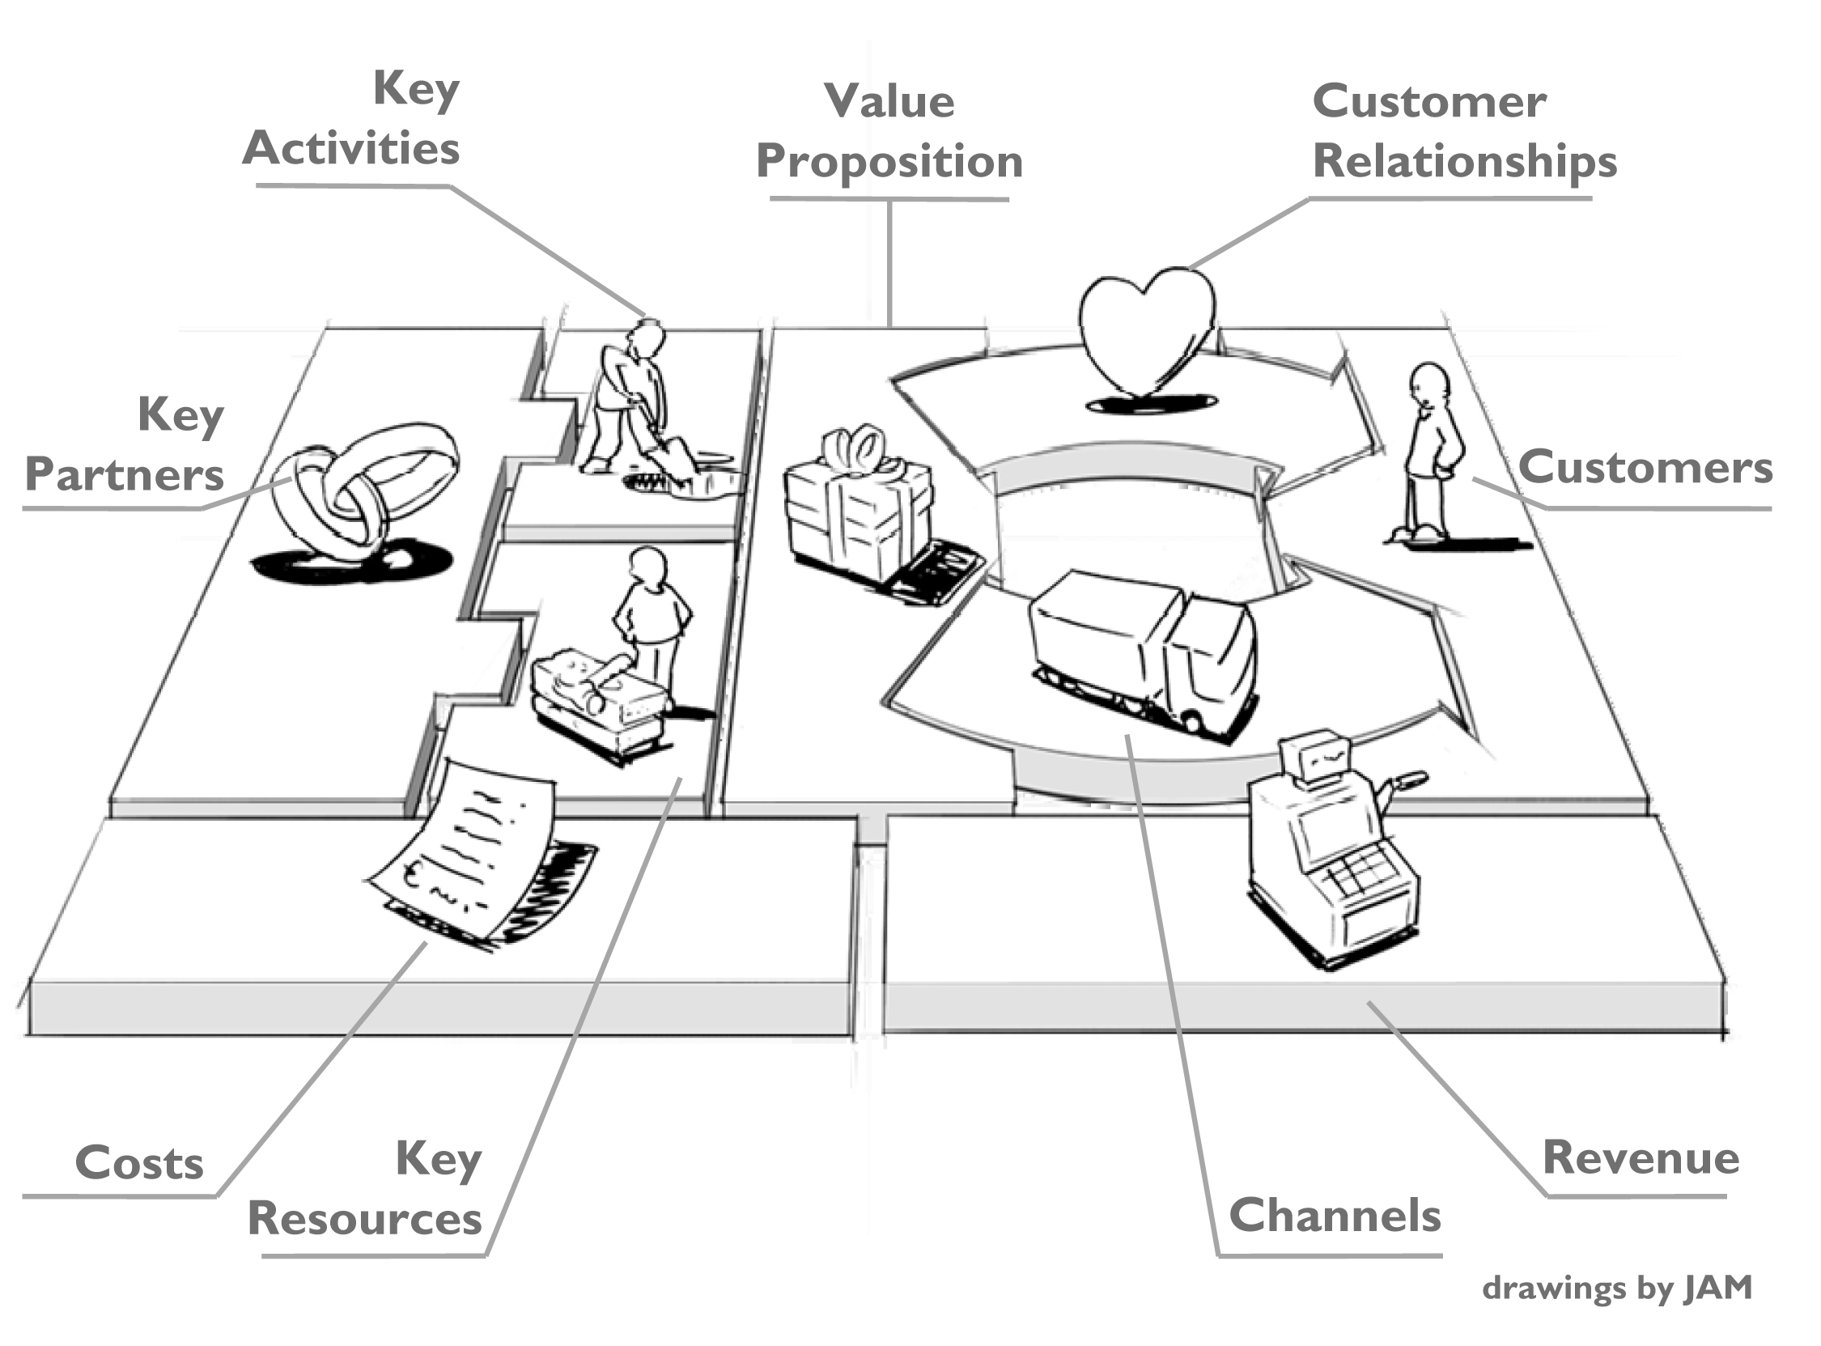
Business Planning starts with considering your business model. A business model can be easily devised by looking at these key 9 building blocks:

- Customer Segments
- Value Proposition
- Channels
- Customer Relationship
- Revenue Streams
- Key Resources
- Key Activities
- Key Partners
- Cost Structure
This section will help you develop your business model, which can then be used in your Business Plan.
Further Action:
Watch the Business Model Canvas video series on Youtube:
http://ow.ly/PVyCC
Customer Segments
The customer segment building block defines the different groups of people or organizations an enterprise aims to reach and serve. Customers comprise the heart of any business and no company can survive without them. Customer groups represent separate segments if:
- Their needs require and justify a distinct offer
- They are reached through different Distribution Channels
- They require different types of relationships
- They have substantially different profitabilities
- They are willing to pay for different aspects of the offer

To identify your customers look back at your Market research- your customers are your Target Market. If you need help to identify them ask yourself the following questions:
Who will be interested in buying your product?

What do you know about them (e.g. their values and buying behaviour)?

Are there sufficient numbers of customers that are easily accessible?

The Value Proposition
The Value Proposition building block describes the bundle of products and services that create value for specific Customer Segment. It does this through a distinct mix of elements catering to that segment’s needs. Values may be quantitative (e.g. price, speed of service) or qualitative (e.g. design, customer experience).
Some Value Propositions can be innovative and represent a new or disruptive offer.
Elements from the following non-exhaustive list can contribute to customer value creation:
- Newness (mobile phones)
- Performance e.g. (faster computers)
- Customization (customizable products)
- Getting the job done
- Design (fashion clothing)
- Brand Status ( Rolex)
- Price
- Cost Reduction (used car-one year service guarantee)
- Accessibility
- Convenience/ Usability (Ipod-Itunes)

What value are you creating for your customers?

Which one of our customer’s problems are you helping to solve?

Which customer needs are we satisfying?

Channels
The Channels Building Block describes how a company communicates with and reaches its Customer Segments to deliver Value Proposition. The Channels are company’s interface with customers. Channels are customer touch points that play an important role in the customer experience. Channels serve several functions:
- Raising awareness among customers about a company’s products and services
- Helping customers evaluate a company’s Value Proposition
- Allowing customers to purchase specific products and services
- Delivering a Value Proposition to customers
- Providing post-purchase customer support
Types of Channels are:
- Sales Force, Web Sales, Own Stores, Partner Stores, Wholesaler
Customer Relationships
This building block describes the types of relationships a company establishes with specific Customer Segments. Customer Relationships may be driven by the following motivations:
- Customer Acquisition
- Customer Retention
- Boosting Sales (Upselling)
Types of customer relationships are:
- Personal assistance (based on human interaction)
- Dedicated personal assistance (dedicating a staff member to customer)
- Self-Service (no direct relationship)
- Automated services ( automated recommendations)
- Communities (online communities, forums)
- Co-Creation ( creating content: YouTube or personalising of products)
Revenue Streams
This Segment represents the cash a company generates from each of Customer segments. Remember that costs need to be subtracted from revenues to create earnings
A business model can involve two different types of Revenue Streams:
- Transaction revenues resulting from one-time customer payments
- Recurring revenues resulting from ongoing payments to either deliver a Value Proposition to customers or provide post-purchase customer support

There are several ways to generate revenue streams:
- Asset sale- selling goods
- Usage fee
- Subscription fees
- Lending renting leasing fees
- Licensing
- Brokerage fees
- Advertising
How much will you sell your product or service for?
Consider who your target audience is and what the market is like. What will potential customers be willing to pay? What are your competitors charging and how you will compare with them? You will also need to take into account the costs you have outlined above and how you will cover these.

Key Resources
Key Resources describes the most important assets required to make a business model work. These resources allow the business to create and offer a Value Proposition, reach markets, maintain relationships with customers and earn revenue. Key resources can be owned or leased by the company or acquired from key partners.
Key resources can be categorised as follows:
- Physical (assests such as manufacturing facilities, buildings, vehicles machines, distribution networks)
- Intellectual ( brands, proprietary knowledge , patents and copyrights and customer databases)
- Human
- Financial (financial guarantees, such as cash, lines of credit)
What are the key resources needed to start and run your business?

Key Activities
Key Activities describes the most important things a company must do to make its business model work. Like Key Resources, they are required to create and offer a Value Proposition, reach markets, maintain Customer Relationships and earn revenues. For example for software maker Microsoft Key activities include software development.
Key activities include:
- Production (designing, making and delivering a product)
- Problem solving ( coming up with new solutions to clients problems)
- Platform/ Network (networks, matchmaking platforms and brands function like a platform, e.g. Ebay website is core to its business model

What are the key activities that your business needs to perform?

Key Partners
Key Partnerships describes the network of suppliers and partners that make the business model work. Companies forge partnerships for many reasons, and partnerships are becoming a cornerstone of many business models. Companies create alliances to optimise their business models, reduce risks or acquire resources.
- We can establish between four different types of partnerships:
- Strategic alliances between non-competitors
- Coopetition: strategic partnerships between competitors
- Joint ventures to develop new businesses
- Buyer-supplier relationships to assure reliable supplies
Who is currently part of your network and what skills and expertise do they have that could benefit your business?

They say it’s all about who you know. As an entrepreneur setting out on your own venture, it’s important to think about your network, who will support you and who can provide skills and expertise which you may not have. Start to list these people here.

Cost Structure
The Cost structure describes all costs incurred to operate a business model. Such costs can be calculated relatively easily after defining Key Resources, Key Activities, and Key Partnerships. It is useful to distinguish between two broad classes of business model Cost Structures: cost-driven and value-driven (many business models fall in between those two extremes.
Cost structures can have the following characteristics:
- Fixed Costs (these remain the same despite the volume of goods or services produced e.g. Salaries rents)
- Variable Costs (these vary proportionally with the volume of goods or services produces)
- Economies of Scale (as output expands the costs advantages are greater e.g. lower bulk purchase rate)
- Economies of Scope (as outreach expands the business has greater cost advantages e.g. marketing)

What costs are involved?
Begin to think about how much it will cost to manufacture your product or deliver your service, and how much it will cost to run your business. Don’t forget to think about overheads such as rent, web hosting, insurance and other day to ay running costs. Begin to list these here and try to estimate how much they will cost.
Overhead/Cost: | Amount:
Rent/Rates and Utilities
Insurance
Design and Manufacturing
It Services and Web Hosting
Marketing
Vehicle and Travel
Wages/Salaries
Fill in Business Model Canvas for your business idea:
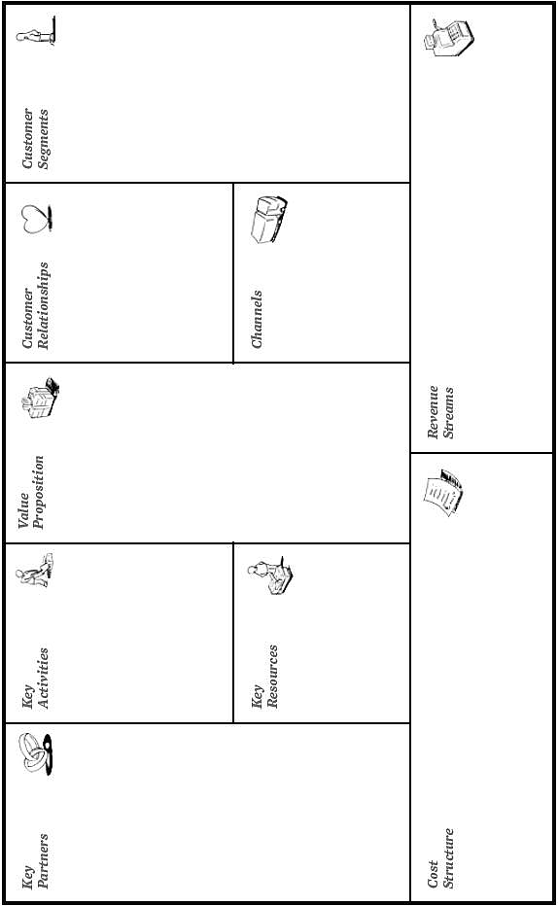

Business Types
Your business will need to operate under a legal structure. Your decision will have Implications for tax, national insurance, accounts and record keeping and how management decisions are made.
When choosing the format of your business you may wish to consider:

- your product or service and the risks involved;
- the types of customers you want;
- he investment and funding;
- the number involved in the business.
Sole traders

Most people who start in business do so as sole traders, working on their own, often from home. They alone receive the income and they alone are therefore liable for any losses or debts. Having no colleagues can be liberating, but may equally be isolating with no one to provide motivation or inspiration.

Partnerships
You could set up in business with one or more colleague(s), relative(s), or friend(s). This form of business relationship is usually known as a partnership. All may be equal partner(s) or some may have a larger share of the business than others. Your income and liability are proportionate to your share in the business. Partnership agreements set up by a solicitor will prevent misunderstanding if circumstances change.
Limited companies
As a limited company, the business is registered with Companies House. It will be a virtual person in the eyes of the law and have separate finances from the owners. There are more regulations associated with running a business this way, but these are generally offset by tax advantages.
Franchises
Franchises provide a way for individuals to start their own businesses with the backing of an established brand and business process. Well-known examples include Domino’s Pizza, Subway, McDonalds, Thornton’s and Toni&Guy.
By making an initial payment which secures equipment, raw materials, training and a well-known commercial name you run a branch of the business ideally making a profit. You can get information and advice from The British Franchise Association (BFA).

Cooperatives
A cooperative is a group of like-minded people with similar aims and business interests. Often community based, co-ops are owned and run democratically and everyone has a say. Profits are returned to members and typically involve employee share schemes. Coops are frequently creative, practical or founded on ethical values.
Freelancing

Freelancers offer a skill or service to other businesses which employ them as needed for particular projects or for set lengths of time. They may be given office space or work from home, delivering work to (often tight) deadlines.

Some freelancers actively market themselves. Others obtain work through agencies or by a direct approach from employers. Professional Contractors Group (PCG) promotes freelancing and provides advice and support.
Social enterprises and charities
Social enterprise is set to increase in importance and presumably investment as the coalition government’s Big Society promotes businesses with social objectives generating surpluses (rather than profit) to benefit local communities as well as regional regeneration and national social policy. Well-known examples include The Big Issue and the Eden Project.
What type of business would you like to set up?
You need to consider which legal operating structure you will choose for your business.
Please tick the relevant box:
- Sole trader
- Partnership
- Limited company
- Limited liability partnership
- Social enterprise

Business Planning
Your business plan is the framework for your business idea. You need a business plan in order to gain credibility, obtain funding and manage risk. Your business plan describes the aims and objectives of your business, its market, strategies and financial forecasts. Generally, a plan highlighting your intentions and ambitions over the next three years will suffice to begin with.
The process of preparing the plan will enable you to evaluate the feasibility of your idea and focus your mind on how to make your business a success. It will become a sales tool, help raise funding, attract potential business partners, suppliers and clients or even persuade reluctant parents. Your aim is to persuade readers that your idea is a viable, and that you have the necessary motivation, skills and business acumen to succeed.
What should a business plan include?
- Business Details such as: owners name, business name, trading address, telephone, mobile, e-mail address, web address

- Executive Summary: Please provide a concise description of your business idea identifying clearly the product or service you plan to supply.

- Personal Profile: In this section, please provide information in respect of your skills, qualifications and experience that have a direct bearing on your business and its chances of success. (e.g., have you worked in this industry before, do you have qualifications that increase your skills and knowledge within this business area.)

- Business Operations
What legal structure will your business be?
What insurances do you need?
Will you register for VAT? YES/ NO
What other legal requirements relate to your business?

- The Market: Please describe your understanding of your target market, how you have researched it and with what results. You should pay particular attention to your target customers, who they are and why they buy the product or service which you are offering. You should explain your understanding of the competition you will face in the market.

- Who are your target customers?
- What customer research have you completed and with what results?
- Why will they buy from you?
- Who are your competitors?

- Goals and objectives: demonstrate that you have clearly defined SMART goals that are:
- specific;
- measurable;
- achievable;
- realistic;
- time-framed.
Include short, medium and long-term goals that describe specific measurable objectives such as market share and revenue/profitability. Break these down further to highlight how you will achieve these objectives.
- SWOT analysis: strength, weakness, opportunities and threats analysis is often done as a part of the process of developing a business plan or a marketing plan. It is a method for assessing your business, its markets, its resources, its competitors and potential problem areas. A SWOT analysis can sometimes reveal opportunities that you had not previously considered or areas of your business that you need to improve.
Strength | Weaknesses
Opportunities | Threats

- Advertising & Promotion: What methods will you use to advertise and promote your business? Explain how you will evaluate the effectiveness of your advertising and promotional activity.

Method | Frequency | Cost (£)

- Business Premises: Where will your business be based? If at home:
  - Will you need a landlord’s permission?
  - Are neighbours likely to object?
  - Will insurance need amending?
  - If from business premises:
  - Types of Premises
  - Size of Premises
  - Basis of occupation e.g., lease/rent
  - Cost e.g., Rent, Business Rates, Water Rates
  - Is planning permission required
  - What improvements are necessary? E.g., Internal Refurbishment, Security Requirements, Disability Access?
- Employing Staff
Are you going to employ staff either at the start of your business or in the first year?
- If YES – When will you employ them? How many staff will you need to employ? Will they be full time or part time? Will you have to set time aside to train your staff?
- How will you recruit your staff? E.g., Pay an employment agency or place advertisements? Do you have job descriptions and interview selection process?
- Who else will be involved in the running of your business?
- Financial Plan:
Include definitions of relevant financial factors, including pricing assumptions, cash-flow, expected sales and profits for your first three up to five years of trading.
Greater detail needed for initial 12 months. Include any financial assistance the business needs (loans, overdrafts, directors’ capital) and demonstrate your business’s ability to repay any borrowing required.

Further Action: Please complete the Cash-Flow forecast exercise.
- Start Up Costs:
Business equipment
List all items of equipment, machinery, vehicles etc., which you will need to operate your business, plus your assessment of the value of each item. Also include costs of rent and insurances, marketing, web design etc.
Overhead/Cost: | Amount:
Rent/Rates and Utilities
Insurance
Design and Manufacturing
It Services and Web Hosting
Marketing
Vehicle and Travel
Equipment
Machinery
Total:

- Personal Survival Budget

Use the form below to work out the minimum income that you need to meet your personal commitments for the next twelve months:

ESTIMATED EXPENDITURE
Housing Cost
Heating
All Personal & Property Insurance
Food & General Housekeeping Expenses
Clothing
Telephone
Hire Charges
Entertainment
Vehicle Running Costs
Savings Plans
Children’s Expenditure / Presents
Contingencies
TOTAL = Expenditure (A)

ESTIMATED INCOME
Income From Partner / Family
Other Income
TOTAL = Income (B)
Total survival income required in the year

- Appendix : any additional details you think will add value to your plan, such as:
- full CVs of the management team;
- promotional material;
- market research results and reports;
- competitor materials;
- details of premises and equipment sought.

All the sections in Business Planning should be included in your Business Plan.

Cash flow Forecasting
It is vital to be able to predict your cash as accurate as possible so it’s a good idea to practice with this exercise.
- Use the information below to fill in the cash flow spreadsheet
- Consider how this will help the company in the exercise?

First Clean
First Clean operates a cleaning business servicing homes and offices. The business employs 4 people and was set up 3 years ago. It relies on new customers and referrals from rental agencies.
The company faces two main problems; first it can struggle to receive payment from customers after work has been carried out. Second, sometimes staff are not gainfully employed because there are no calls.
The managing director is about to draw up the cash flow forecast for the next trading year. The forecast monthly sales can be seen below.
Jan | Feb | Mar | Apr | May | Jun | Jul | Aug | Sep | Oct | Nov | Dec
6000 | 5800 | 5500 | 6500 | 6600 | 6000 | 6800 | 6700 | 6800 | 7000 | 6900 | 7200

- Salaries are expected to be £4000 per month
- Travel expenses are expected to be £650 per month
- Telephone charges are expected to be £150, £150, £170 and £170 in March, June, September and December
- Insurance is £450 and paid in July
- Professional fees will include accountancy fees of £700 in December and Marketing, £300 in February and £300
- Drawing of £1000 are made by the MD each month
- Annual rent of £4000 is payable in June
- An allowance of £200 a month is made for miscellaneous expenditure
- The opening balance for First Clean is £850

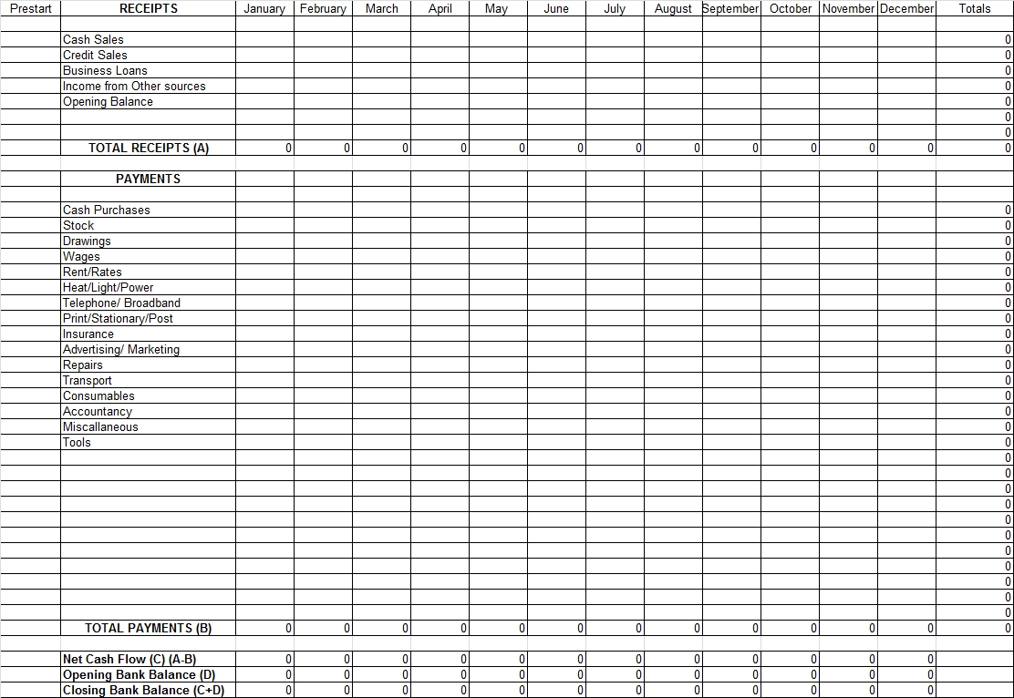

Preparing your business pitch
Whether you’re looking for investment to get your idea off the ground, trying to make new contacts and expand your network, or you’re trying to sell your product or service to a new client, it is essential that you have a powerful and persuasive business pitch.
You need to have an ‘elevator pitch’ ready, as you never know who you’ll meet! This is an overview of your business, designed to leave the potential investor or customer wanting more. Think about what makes your business unique and highlight the most attractive selling points. Briefly cover financials but keep it short and snappy! Get their interest and be prepared to follow this up with more information.
Once you’ve got their attention, you will also need to deliver longer pitches covering more detail about your business. Preparation is key! Here are some of our top pitching tips:
- Know your audience – dress appropriately, use language they will understand and only tell them the information they want to hear.
- Know your business – sell your USP, understand your market and have a full understanding of your facts, figures and timelines.
- Be articulate – sell you skills, qualities, knowledge and achievements.

Resources and Finance
Funding comes in four main types:

- Personal or business loan from banks which is funding that you have to pay back, often with interest
- Investment, which is equity that is put into your firm and may give the investor a say in the way it is run from venture capitalists or business angels;

- Matched funding, where another agency supplies part of the cash needed (typically half of the amount) and you have to obtain the rest;

- Grants, awards and scholarships that do not have to be repaid.
Using your own savings and assets (e.g. car, house) may be cost effective and will reveal added personal commitment when seeking further financial support.
Investments from friends and family are likely to be made with minimal interest rates, but may not provide the on-going mentoring and support available from other sorts of funders. Either way a legal contract should be drawn up in case disputes arise later.
Awards and competitions are another source of funding. Two examples are Prince's Trust and Shell-Livewire nationally. Trade associations and professional bodies may offer grants and sponsorships.

University of Salford Start-Up Grants
Start Up Award – Awards Up To £1,000
Start Up Award funding is a student only award, for individuals with a business idea. This funding can go towards finding out if your idea is viable, learning more about what is needed and trying the project on a small scale before further development.
http://www.careers.salford.ac.uk/page/startupawards

Make THE Difference Award – Awards Up To £1,000
Make THE Difference Awards help to fund and supporting students and recent graduates of the University who have a passion and an idea to make a difference in their community. This funding is for people with vision, drive and commitment to change the world for the better.
http://www.careers.salford.ac.uk/page/makethedifference
Other Sources of Funding
Shell Live-wire
- Promoting enterprise among 16-30 years olds
- Information and advice
- Annual Awards
- http://www.shell-livewire.org/
The Prince’s Trust
- Support for 18 0 30 year olds
- Financial and business support
- Up to £5,000 start-up loans
- http://www.princes-trust.org.uk/

Rockstar Youth
- Support for 18 0 30 year olds
- Financial and business support
- Up to £10 000 start-up loans
http://www.rockstaryouth.co.uk/start-up-loan/
Business Growth Hub
- Support and information
- Links to finance
- http://www.businessgrowthhub.com/service-categories/finance-products

  - Innovation Competitions and Grants
https://www.innovateuk.org/funding-competitions
  - UK Business Angels Association http://www.ukbusinessangelsassociation.org.uk/
- British Venture Capitalist Association http://www.bvca.co.uk/

  - North West Business Angels www.nwbusinessangels.co.uk
  - Start-up Loans – Government scheme http://www.startuploans.co.uk

  - “Bank of Dave” – Burnley Savings & Loans www.burnleysavingsandloans.co.uk

  - “Envestors” - www.envestors.co.uk

  - Crowd Funding www.fundingcircle.com www.crowdfunding.com

  - Seed Enterprise Investment Scheme www.hmrc.gov.uk/seedeis/index.htm

  - Regenerate Pennine Lancashire www.regeneratepl.co.uk

  - Bolton Business Ventures www.bbvonline.net

  - North West Fund www.thenorthwestfund.co.uk

  - Enterprise Venture – Rosebud Fund www.evgroup.uk.com

  - Manufacturing Advisory Service www.mymas.org

Where will you be getting the funds to fund your business?

Type of Finance | Amount (£)
Own capital (Cash provided by you)
University Start Up Grant
Rockstar Youth Loan
Prince’s Trust Grant
Prince’s Trust Loan
Other Grants
Start-Up loan Bank Loan
Bank Overdraft Facility

Register Your Business:
Sole Trader
As a business owner, you may be liable for several different taxes, including income tax,
VAT, stamp duty and business rates. Go to HM Revenue & Customs
(HMRC) to find out more about what taxes will apply to you, how to calculate them and
when to send your tax return to them. New businesses can sometimes receive tax advantages on equipment, premises or for research and development.
HMRC have plenty of resources online including webinars that tell you all about how to register, tax for the self-employed and book-keeping.
http://www.hmrc.gov.uk/selfemployed/index.shtml http://www.hmrc.gov.uk/webinars/self-employed.htm
Companies
If you would like to register as a Company please visit companies house.
http://www.companieshouse.gov.uk/
References

Business Growth Hub, (2014), Start Smart Workbook, Retrieved August 2014 www.businessgrowthhub.com
Careers Development Service, University of Leicester, (2014) My Business Start-Up Coaching Workbook, Retrieved Aug 2014 www.le.ac.uk/careers
Laing, D. (2011) AGCAS Guide to Self-Employment, Retrieved in Aug 2014, University of Manchester, www.agcas.org.uk
Osterwalder, A. & Pigneur, Y. ( 2010) Business Model Canvas, New Jersey: John Wiley & Sons, Inc.

Adapted from Laing D. (2011) AGCAS Guide to Self-Employment, University of Manchester, Retrieved in Aug 2014 (www.agcas.org.uk)
From Laing D. (2011) AGCAS Guide to Self-Employment, University of Manchester, Retrieved in Aug 2014 (www.agcas.org.uk)
From Business Growth Hub,(2014) Start Smart Workbook, Aug 2014, www.businessgrowthhub.com
From Business Growth Hub (2014) Start Smart Workbook, Aug 2014, www.businessgrowthhub.com
From Careers Development Service, University of Leicester(2014) My Business Start-Up Coaching Workbook, , Retrieved Aug 2014, www.le.ac.uk/careers
From Business Growth Hub (2014) Start Smart Workbook, Aug 2014, www.businessgrowthhub.com
From Business Growth Hub (2014), Start Smart Workbook, Aug 2014, www.businessgrowthhub.com
From Careers Development Service, University of Leicester (2014) My Business Start-Up Coaching Workbook, , Retrieved Aug 2014, www.le.ac.uk/careers
Adapted from Careers Development Service, University of Leicester (2014) My Business Start-Up Coaching Workbook, , Retrieved Aug 2014, www.le.ac.uk/careers
From Careers Development Service, University of Leicester (2014) My Business Start-Up Coaching Workbook, , Retrieved Aug 2014, www.le.ac.uk/careers
From Osterwalder, A. & Pigneur, Y. ( 2010) Business Model Canvas ,New Jersey: John Wiley & Sons, Inc.
From Osterwalder, A. & Pigneur, Y. ( 2010) Business Model Canvas ,New Jersey: John Wiley & Sons, Inc.
From Osterwalder, A. & Pigneur, Y. ( 2010) Business Model Canvas ,New Jersey: John Wiley & Sons, Inc.
From Osterwalder, A. & Pigneur, Y. ( 2010) Business Model Canvas ,New Jersey: John Wiley & Sons, Inc.
From Osterwalder, A. & Pigneur, Y. ( 2010) Business Model Canvas ,New Jersey: John Wiley & Sons, Inc.
From Careers Development Service, University of Leicester(2014) My Business Start-Up Coaching Workbook, , Retrieved Aug 2014, www.le.ac.uk/careers
From Osterwalder, A. & Pigneur, Y. ( 2010) Business Model Canvas ,New Jersey: John Wiley & Sons, Inc.
From Osterwalder, A. & Pigneur, Y. ( 2010) Business Model Canvas ,New Jersey: John Wiley & Sons, Inc.
From Osterwalder, A. & Pigneur, Y. ( 2010) Business Model Canvas ,New Jersey: John Wiley & Sons, Inc.
From Careers Development Service, University of Leicester (2014) My Business Start-Up Coaching Workbook, , Retrieved Aug 2014, www.le.ac.uk/careers
From Osterwalder, A. & Pigneur, Y. ( 2010) Business Model Canvas ,New Jersey: John Wiley & Sons, Inc.
From Careers Development Service, University of Leicester (2014) My Business Start-Up Coaching Workbook, , Retrieved Aug 2014, www.le.ac.uk/careers
From Laing, D. ( 2011) AGCAS Guide to Self-Employment, University of Manchester, Retrieved in Aug 2014 www.agcas.org.uk
From Business Growth Hub (2014) Start Smart Workbook, Aug 2014, www.businessgrowthhub.com
From Business Growth Hub (2014) Start Smart Workbook, Aug 2014, www.businessgrowthhub.com
From Business Growth Hub (2014) Start Smart Workbook, Aug 2014, www.businessgrowthhub.com
From Laing D. (2011) AGCAS Guide to Self-Employment, University of Manchester, Retrieved in Aug 2014 (www.agcas.org.uk)
Adapted From Business Growth Hub (2014) Start Smart Workbook, Retrieved Aug 2014, www.businessgrowthhub.com
From Careers Development Service, University of Leicester (2014) My Business Start-Up Coaching Workbook, Retrieved Aug 2014, www.le.ac.uk/careers
From Laing, D. (2011) AGCAS Guide to Self-Employment, University of Manchester, Retrieved in Aug 2014, www.agcas.org.uk

