Adding UniSkills to your Blackboard Module enables students to self-enroll and access UniSkills directly from your module area.
Once UniSkills is added to your course menu you can direct students to it using a course link within announcements or from another relevant module page such as learning materials or assessments.
Instructions
- Ensure you have the UniSkills.zip file saved to your computer.
- Login to the Blackboard module you want to add the UniSkills content to.
- From the Control Panel expand the Packages and Utilities heading.
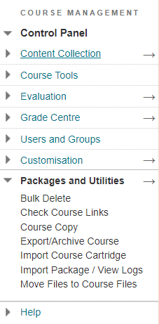
- Select Import Package /View logs.
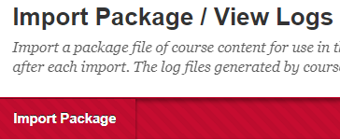
- Click on the Import Package button at the top of the page.
- Under Select a Package, click on Browse my computer and navigate to the Uniskills.zip file saved on your computer.
- Under Select Course Material, tick the Content Areas option.
- Click Submit. Confirmation will display in a green bar at the top of the page.
- An email will be sent to you once the process is complete.

